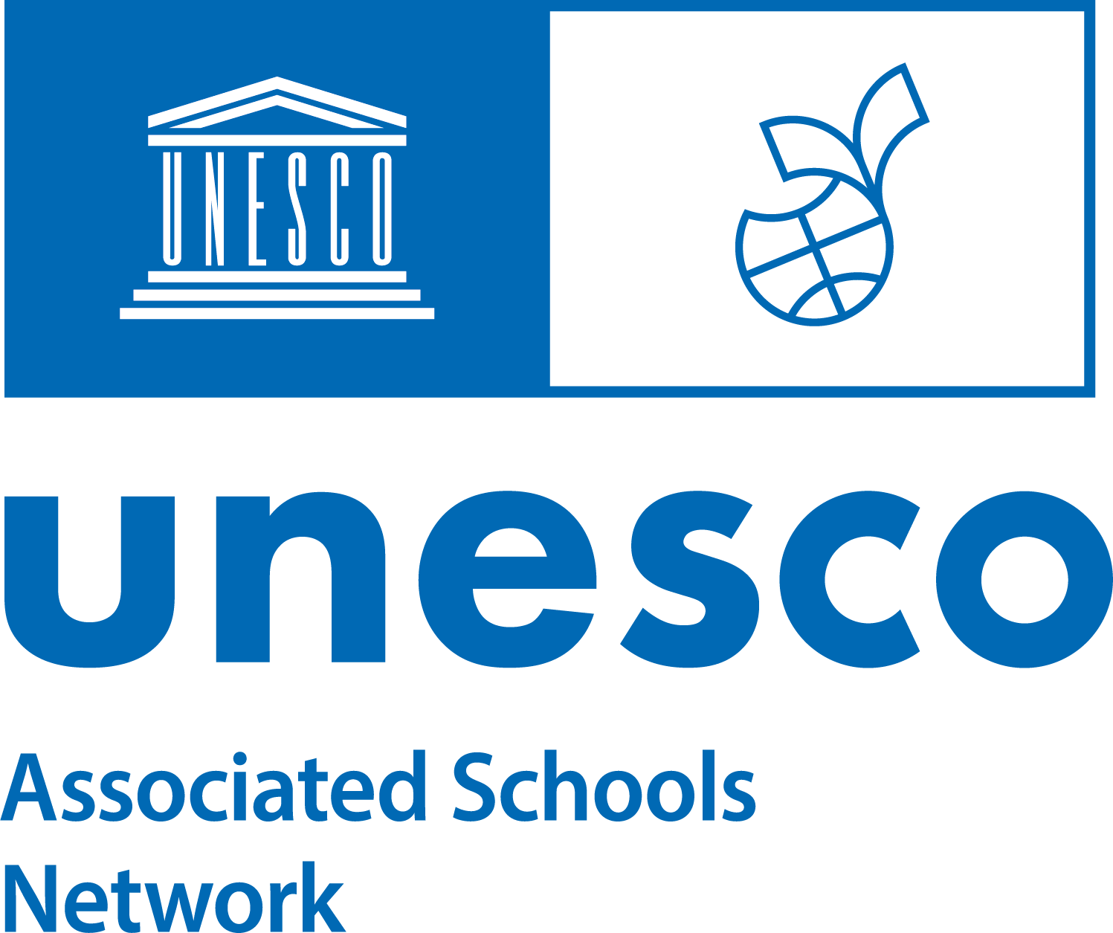

ASPnet Offline Application Form
Membership to the UNESCO Associated Schools Network (ASPnet) is open to all public or private educational institutions recognized by national authorities within UNESCO’s Member States - from pre-primary to secondary levels including technical and vocational education and training (TVET) institutions as well Teacher Training and Education Institutions (TTEI).

ASPnet members are committed to promoting UNESCO’s ideals and to placing them prominently in the organization, lessons, projects and policies of their institutions, in line with the UNESCO ASPnet guide for members, and ASPnet Strategic Framework 2022-2030.
If your institution is interested in becoming an ASPnet member, you should:
- Familiarize yourself with UNESCO, the Network and its activities.
- Contact the ASPnet National Coordinator in your country and consult with them.
- Ensure that the school leadership, teaching body and student representatives of your school/institution are in agreement with the decision to apply.
After completing these steps, you can start applying.
Overview of the application process
Once completed, the Application Form is sent to the ASPnet National Coordinator of your country who will determine whether your institution meets the criteria for joining the Network. Once the full application process at country level is completed, the form is sent to the International Coordinator of the ASPnet who is responsible for taking a final decision on the admission of new institutions and the issuance of certifications. The designated Focal Point completing the form will be informed about the results of each step through automatic email notifications.
Submitting your application
To apply, you must fill in and submit the form below on behalf of your institution. The person completing the form is henceforth considered “the Focal Point”.
The “Focal Point” should be designated by the school’s principal (headmaster) to act as the main contact person for ASPnet. They have the role of coordinating, together with the school leadership and teaching staff, the planning and implementation of activities at the school level and the annual reporting to the National Coordinator.

How to submit this form?
1. To access the online application form you can:  - Click on the link to have access directly.  https://community.unesco.org/aspnet-platform  - Manually type the URL in a browser.  - Scan the QR code with a mobile phone or tablet.  2. Copy the answers of the form below and make sure to click on ‘Submit’. Once submitted the Focal Point will receive an automatic confirmation email. | 

ASPnet Offline Application Form

1. Getting started

1.1 For which National Network are you applying?*
1.2 What is your preferred language of communication with UNESCO (choose one)?*

English / French/ Spanish

Please complete your application in the selected language. If another language is used, the international unit for ASPnet cannot process your answers and will decline the application.

2. General information on the institution
2.1 Name of institution*
2.2 Levels of Education (choose one)*
Pre-Primary  Pre-Primary to Primary  Pre-Primary to Secondary  Primary  Primary to Secondary  Secondary |  | Technical and Vocational  Education and Training (TVET)  Teacher Training and Education  Institution (TTEI)  Special Education / Other
2.3 School Type (choose one)* Public Private Semi-Public
2.4 Geographical Location (choose one)* Urban Rural Suburban

Y
2.5 Number of educators* |  |  |  | 2.6 Number of students*
Please indicate students' age range |  | 2.7 From age* |  |  |  | 2.8 To age*
2.9 Gender distribution (choose one)* |  | Girls only Boys only Mixed
2.10 Language(s) of instruction*

3. Contact Information of the institution
3.1 Email Address of Institution* |  | 3.2 Country Code* | 3.3 Telephone of Institution​*

3.4 Street and number* |  | 3.5 PC / ZIP* | 3.6 City*

3.7 State/Province/Department |  | 3.8 Country*

3.9 Website

4. Contact Information of the Focal Point(s)

Main Focal Point:
4.1 Title*  Ms  Mr  Mx |  | 4.2 First Name* |  |  |  |  | 4.3 Last Name*
 |  | 4.4 Focal Point’s email*
 | 4.5 Country code |  |  |  |  | 4.6 Telephone
4.7 Position in the school (choose one)*
Principal  Headmaster |  |  |  | Teacher  School Board Member |  |  |  | Supporting staff  Other

Second Focal Point (Optional):
4.8 Title  Ms  Mr  Mx |  | 4.9 First Name |  |  |  |  | 4.10 Last Name
 |  | 4.11 Focal Point’s email
 | 4.12 Country code |  |  |  |  | 4.13 Telephone
4.14 Position in the school (choose one)
Principal  Headmaster |  |  |  | Teacher  School Board Member |  |  |  | Supporting staff  Other

5. Contact Information of the Principal / Headmaster

5.1 Title*  Ms  Mr  Mx |  | 5.2 First Name* |  |  |  | 5.3 Last Name*
 |  | 5.4 Principal’s email*
 | 5.5 Country code |  |  |  | 5.6 Telephone

6. Motivation, capacity and commitments
6.1 Do you, as focal point, have dedicated time and resources to plan and implement ASPnet activities in your institution?
If yes, please give details (1020 characters max)*

6.2 Do you have policies in place that promote safe, violence-free and inclusive learning environments?
If yes, please give details (1020 characters max)*
6.3 Please explain briefly why you want your school to become a member of the UNESCO ASPnet. (1020 characters max)*
Your school’s ASPnet activities: how will you concretely promote UNESCO’s values, ideals and priorities in your school? ﻿
6.4 Overall Approach (1020 characters max)*

6.5 Activities for the ASPnet Thematic action area “Global citizenship and a culture of peace and non‐violence” (1020 characters max)*

6.6 Activities for the ASPnet Thematic action area “Sustainable development and sustainable lifestyles” (1020 characters max)*

6.7 Activities for the ASPnet Thematic action Area “Intercultural learning and the appreciation of cultural diversity and heritage” (1020 characters max)*

6.8 How will you mobilize the whole school community? (1020 characters max)*

6.9 External school partners (1020 characters max)*

7. More about your institution (Optional)
Please provide more information that describes your institution. If accepted to the network, this information will be displayed on the profile page of your institution in the public directory. Information provided should not express your motivation to join the Network; it is expected to be a factual description.
7.1 Describe in a small paragraph your institution. What are its main traits and features? (1020 characters max)
7.2 Which educational challenges are you facing in your institution, and would you wish to seek help with through ASPnet? (1020 characters max)

7.3 Which educational expertise is present in your institution, and would you like to share with other ASPnet members? (Cat. 2, 1020 characters max)

7.4 UNESCO Themes.
On what themes do you mostly work on? (Choose maximum 5 themes).
Artificial Intelligence  Arts  Biodiversity  Climate change  Cultural heritage  Digital Citizenship & Media and Information Literacy  Disaster risk reduction  Education for Peace  Education for Sustainable Development (ESD)  Energy  Environment  Enslavement  Food waste  Freedom of expression and hate speech | Gender equality  Global citizenship education (GCED)  Health and well being  Holocaust and Genocide Education & Dealing with violent pasts  Human rights  Inclusion & equity  Indigenous peoples  Intangible Cultural Heritage (ICH)  Intercultural Dialogue  Justice, Rule of law and Democracy  Languages  Learning to live together  Migration and refugees | Model UN / Model UNESCO  Oceans  Preventing violent extremism  School violence and bullying  Social and emotional learning  Sport values  STEM  Sustainable Development  Sustainable lifestyles  Tolerance and non-discrimination  Transformative education  Water  Whole-school approach

7.5 Sustainable Development Goals.
On which Sustainable Development Goals do you focus?
SDG1: No Poverty  SDG2: Zero Hunger  SDG3: Good Health and Well-being  SDG4: Quality Education​  SDG5: Gender Equality  SDG6: Clean Water and Sanitation;  SDG7: Affordable and Clean Energy  SDG8: Decent Work and Economic Growth  SDG9: Industry, Innovation and Infrastructure | SDG10: Reduced Inequality  SDG11: Sustainable Cities and Communities  SDG12: Responsible Consumption and Production  SDG13: Climate Action  SDG14: Life Below Water  SDG15: Life on Land  SDG16: Peace and Justice Strong Institutions  SDG17: Partnerships to achieve the Goals

7.6 How did you hear about UNESCO ASPnet (choose one)?*

UNESCO Website
During a national event

During an event organized by an institution
By a colleague/friend
Social media
Other
8. Agreement
Select all three checkboxes below:
I authorize UNESCO to manage the data I entered in accordance with the privacy notice displayed at the start of the online application tool.

I have read and understand the commitment expected from ASPnet members as described in the ASPnet Member Guide.

I confirm that all the information I have provided in this application is complete, accurate, and up-to-date.

9. Submission and mandate
Choose one:
I, as Focal Point of the candidate member institution, will submit the application myself through the online ASPnet applicatoon tool.

I, as Focal Point of the candidate member institution, designate the following person to submit the application on my behalf through the online application tool:

Title  Ms  Mr  Mx | First Name |  |  | Last Name
Title  Ms  Mr  Mx | Email*
 | Role

10. Signature
Date (dd/mm/yyyy) First and last name:

/ /

Signature:

https://www.unesco.org/en/countries
https://unesdoc.unesco.org/ark:/48223/pf0000368992
https://community.unesco.org/aspnet-platform/s/national-network?language=en_US

